
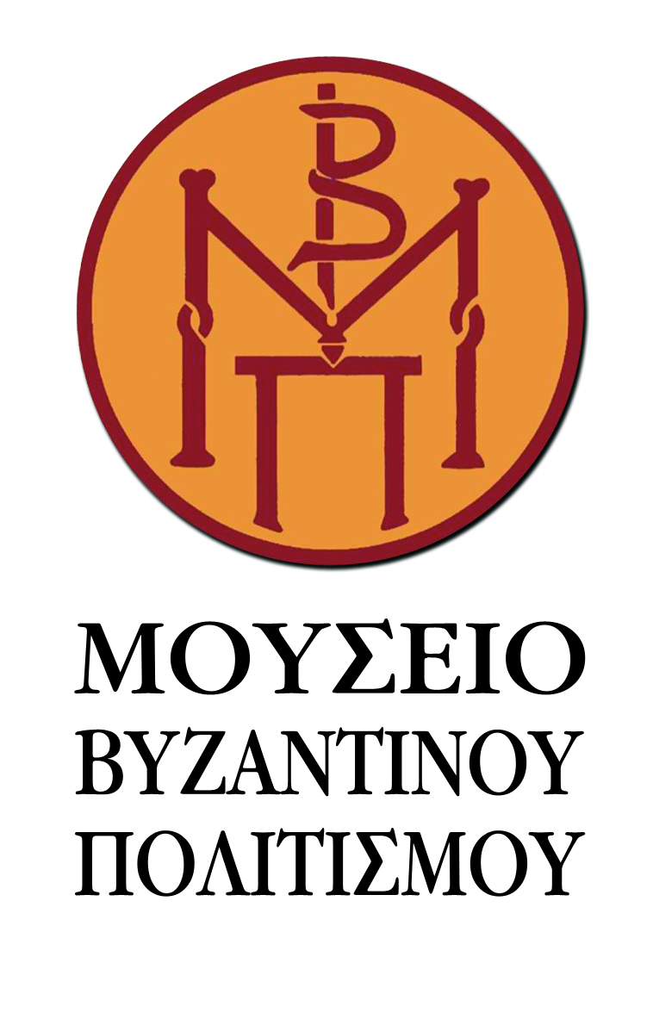
Thessaloniki June 17, 2016
PRESS RELEASE
“Greek Religious Icons, a Greece - Russia communication way” is the new temporary exhibition organized within the framework of the cultural events celebrating 2016 as Year of Greece in Russia, Russia in Greece. The exhibition is the result of the collaboration between the Museum of Byzantine Culture in Thessaloniki and the State Museum of History of Religion in Saint Petersburg.
Featuring sixty-seven (67) works from the engraving collections of the two Museums, the exhibition presents a representative image of the Orthodox engravings of the period 17th-20th centuries, seeking to reveal the common features in the cultural heritage of the two peoples. The Museum of Byzantine works come from the Dori Papastratou collection, a unique on an international level and highly appreciated collection, which was generously donated to the Museum. Thirty-one (31) etchings and lithographs printed on paper and fabric along with 3 copper plates that are not displayed in the Museum’s permanent exhibition are for the first time presented in Russia, while a part of them is also for the first time displayed in Greece and abroad. Initially, the exhibition will be presented in Saint Petersburg (State Museum of the History of Religion, June 21st to July 26th, 2016), and next it is going to travel back to Thessaloniki, twin city of Saint Petersburg since 2002 (Museum of Byzantine Culture, October 20th to late November 2016).
Sponsors:


Media Sponsors:
